

Wachemo University College of Engineering and Technology Department of Software Engineering Course: Software Engineering Tools and Practice B.Sc. In Software Engineering
Group member
Name ID
Marefu Abebe-----------------------------------1501067.
Gurmesa Ayele------------------------------ ---150091.
Tewodros Kifle----------------------------------150134.
Tut Gatwech Tut--------------------------------------1501376.
Niguse Derribe-------------------------------------------150119.

Date: Wednesday, 7 May 2025

Our Instructor :Mr.Feyisa.k
Wachemo University, Hosaena, Ethiopia

Abstract
The rapid advancement of technology has significantly transformed various industries, including the food and hospitality sector. This project presents the design and development of an Online Food Order and Delivery System, aimed at streamlining the process of ordering food and enhancing the overall efficiency of food delivery services. The system is designed to bridge the gap between customers and food service providers through a convenient, user-friendly, and efficient online platform.
The proposed system allows customers to browse various menus, place orders, and make secure payments from the comfort of their homes or workplaces. It also enables restaurant owners and administrators to manage orders, update menus, monitor deliveries, and track customer feedback in real-time. Delivery personnel are also equipped with a dedicated interface to receive, update, and confirm delivery statuses. This ensures smooth coordination among all stakeholders involved in the process.
From a technical perspective, the system has been developed using modern web technologies, incorporating essential features such as real-time order tracking, role-based access control, notification systems, and a responsive user interface. The system also addresses key functional and non-functional requirements including usability, performance, scalability, and security.

Acknowledgments

First and foremost, we would like to thank the Almighty God for granting us the strength, determination, and perseverance to complete this project successfully.
We would like to express our heartfelt gratitude to our instructor Mr.Feyisa.k for their continuous guidance, encouragement, and constructive feedback throughout the development of this project. Their expertise and support were instrumental in helping us understand the practical applications of software engineering tools and practices.
Our sincere thanks also go to the College of Engineering and Technology, Department of Software Engineering, Wachemo University, for providing the necessary resources and a conducive learning environment for this project.
We are also grateful to our classmates and friends who shared their insights, suggestions, and moral support during the different stages of the project.
Lastly, we acknowledge the efforts and dedication of all our team members for their collaboration, creativity, and commitment in bringing this Online Food Order and Delivery System to life.
Table Title | Page
Table 1.4.1: Key Elements of the Use Case Diagram | 10
Table 1.4.2: Use Case Identification | 12
Table 4.1-1: Use case description for create account/registration | 15
Table 4.1-2: Use case description for Login | 16
Table 4.1-3: Use case description for Logout | 17
Table 4.1-3: Use case description for Reset Password | 19
Table 4.1-4: Use case description for Manage Profile | 20
Table 4.1-5: Use case description for Track Delivery | 20
Table 4.1-6: Use case description for Manage Users | 21
Table 4.1-7: Use case description for Assign Roles | 22
Table 4.1-8: Use case description for View Reports | 23
Table 4.1-9: Use case description for Manage Menus | 24
Table 4.1-10: Use case description for Confirm Orders | 24
Table 4.1-11: Use case description for Update Order Status | 25
Table 4.1-11: Use case description for View Delivery Assignments | 26
Table 4.1-12: Use case description for Update Delivery Status | 27
Table 4.1-13: Use case description for Browse Restaurants | 27
Table 4.1-13: Use case description for Place Order | 28
Table 4.1-14: Use case description for Make Payment | 29
Table 4.1-15: Use case description for Rate Food | 31
Table 4.1-16: Use case description for Process Payment | 32
Table 4.1-17: Use case description for Verify Payment | 32
Table 4.1-17: Use case description for Generate Receipt | 33
Table 3.1: Key Concepts of Low-Level Design for Online Food Order and Delivery System | 51
Table 3.2: Class Design Steps for Online Food Order and Delivery System | 51
Table 4.1: Class Diagrams | 58
Table 4.2: Steps to generate code from class diagram | 59
Table 3.2 Define Attributies | 55

Figure Title | Page
Figure 2.3-1: Sequence diagram for create account | 44
Figure 2.3-2: Sequence diagram for Log In | 45
Figure 2.3-3: Sequence diagram for Log out | 46
Figure 2.3-4: Sequence diagram for Assign Roles | 47
Figure 2.3-5: Sequence diagram for Make Payment | 48
Figure 4.1-1: Use case diagram for Online Food Order and Delivery System | 15

References

[1] S. E. Kimes, The Current State of Online Food Ordering in the U.S. Restaurant Industry, Cornell University, Cornell Hospitality Report, 2011.
[2] A. Kapoor and M. Vij, "Technology Adoption in Online Food Ordering and Delivery Services," Int. J. Res. Eng. IT Soc. Sci., vol. 8, no. 1, pp. 214–219, 2018.
[3] A. Ray, "Online Food Delivery Services: Issues and Challenges," Int. J. Res. Anal. Rev., vol. 6, no. 1, pp. 232–239, 2019.
[4] D. Mehta and A. Chug, "A Study on the Consumer Perception Towards Online Food Ordering and Delivery Services," Int. J. Res. Eng. Sci. Manag., vol. 3, no. 9, pp. 143–148, 2020.
[5] S. S. Rathore and M. Chaudhary, "Consumer's Perception on Online Food Ordering," Int. J. Manag. Bus. Stud., vol. 8, no. 4, pp. 12–17, 2018.
[6] Statista Research Department, "Online Food Delivery – Global Market Size 2023," Statista. [Online]. Available: https://www.statista.com/statistics/1095146/online-food-delivery-market-size-worldwide/. [Accessed: May 7, 2025].
[7] Zomato, "Annual Report 2022," Zomato Investor Relations. [Online]. Available: https://www.zomato.com/investor-relations. [Accessed: May 7, 2025].
[8] Uber Technologies Inc., "Uber Eats Business Overview and Growth Strategy," Uber Newsroom. [Online]. Available: https://www.uber.com/newsroom/. [Accessed: May 7, 2025].
Catalog
Abstract II
Acknowledgments III
References 3
Chapter one 4
1.1 System Introduction 4
1.2 Requirement Analysis (Use Case) 5
1.3 Requirement Specifications 5
1.4 Use Case Diagram Components 8
1.4.1Use-Case Identification. 9
1.4.3:Description of Use-Case/template. 13
Basic Information 26
Preconditions 27
Main Flow (Normal Scenario) 27
Alternative Flow A1: Payment Success 27
Alternative Flow A2: Payment Failure 27
Postconditions 28
Chapter Two 32
2.1 High-Level Sequence Diagram 32
Chapter Three 45
Tools 49
Steps to Draw the Low-Level Class Diagram 49
4.1 Implementation 52
Table 4.1: Class Diagrams 52
4.2 Steps to generate code from class diagram 53

Chapter one

1.1 System Introduction
The Online Food Order and Delivery System is a web-based platform designed to streamline the process of ordering food from local restaurants and delivering it directly to customers' doors. This system enables customers to conveniently browse restaurant menus, place orders, and track deliveries from their mobile devices or computers. Restaurants can manage their offerings and update order statuses in real time, while delivery personnel can view delivery requests and update delivery progress. The system also incorporates administrative features to monitor platform usage and ensure operational integrity.
The primary goal of this system is to create a seamless, efficient, and user-friendly experience for all stakeholders involved in the food ordering ecosystem. Through this platform, the system minimizes communication delays, reduces human error, and enhances customer satisfaction by offering transparent and real-time information on order and delivery statuses

1.2 Requirement Analysis (Use Case)

Requirement analysis is the foundational phase in software engineering that determines the goals, needs, and expectations from the end users’ perspective. This process is essential for building a system that not only functions correctly but also aligns with user expectations and business objectives. For the Online Food Order and Delivery System, this phase helps in identifying the system’s scope, required features, and user roles.
Purpose of Requirement Analysis
- To understand and capture what functionalities the system must perform.
- To define the boundaries of the system and its interaction with external entities.
- To prepare documentation that guides the design, development, and testing phases.
In this case, the goal is to develop a comprehensive online platform where customers can order food from various restaurants, restaurants can manage menus and process orders, delivery personnel can fulfill deliveries, and administrators can oversee the entire platform.
The following functional requirements were gathered:

1.3 Requirement Specifications

1.3.1 Functional Requirements
Common Functional Requirements for All Actors
User Login/Logout: Enable all users to log in and out securely with proper authentication.
Password Reset: Allow all users to reset their passwords securely in case of forgotten credentials through email verification.
Update Credentials: Enable all users to update their login credentials (username or password).
Manage Profile: Allow all users (except administrators) to update or delete their profile information, including contact details and personal preferences.
User Registration: Allow all users (except administrators) to register and create their profiles with necessary details such as name, contact information, and role.
Administrator Functional Requirements
Approve/Reject Registrations: Allow administrators to review and approve or reject user registration applications for customers, restaurants, and delivery personnel.
Assign/Revoke User Roles: Enable administrators to assign roles (e.g., customer, restaurant, or delivery personnel) or revoke them based on the user’s registration details and status.
Manage User Permissions: Enable administrators to grant or revoke permissions for users based on their roles and access requirements (e.g., allowing restaurants to edit menus or delivery personnel to update order statuses).
Activity Reporting: Allow administrators to generate system reports on order activities, user actions, payments, and other relevant data to monitor performance and usage.
Restaurant Owner Functional Requirements
Manage Menu: Allow restaurant owners to add, edit, or remove food items from the restaurant menu, including descriptions, pricing, and availability.
Confirm Orders: Enable restaurant owners to review and accept or reject incoming orders based on availability and order details.
Update Order Status: Allow restaurant owners to update the order status from preparing to completed, providing real-time updates to customers.
Manage Restaurant Profile: Allow restaurant owners to manage their restaurant’s profile, including name, contact details, location, and operational hours.
Review Customer Ratings: Allow restaurant owners to view customer feedback and ratings for their food items and services.
Delivery Personnel Functional Requirements
View Delivery Assignments: Enable delivery personnel to view assigned orders, including pickup and drop-off locations, delivery timelines, and order status.
Update Delivery Status: Allow delivery personnel to update the delivery status, such as "Picked up" or "Delivered" upon completing the task.
Delivery Navigation: Provide drivers with map navigation tools to help them navigate efficiently to the customer’s location for pickup and delivery.
Driver Dashboard: Allow delivery personnel to track earnings, completed deliveries, and current tasks from a personal dashboard.
Customer Functional Requirements
Browse Restaurants: Enable customers to search and filter nearby restaurants based on categories, cuisine types, or ratings.

Place Order: Allow customers to select food items from a restaurant menu and place an order, adding special instructions if needed.
Make Payment: Provide customers with secure options to pay for food orders through integrated payment gateways.
Track Delivery: Allow customers to track the real-time status of their order and its delivery progress.
Rate and Review: Enable customers to leave a rating and review for restaurants and delivery personnel after the order is completed.
View Order History: Allow customers to view past orders, including details and status updates.
Payment Gateway Functional Requirements
Process Payment: Handle secure payment transactions through integrated payment gateways, ensuring that all payment data is encrypted.
Verify Payment: Verify payment success or failure and notify customers and restaurants accordingly.
Generate Receipt: Produce digital receipts after successful transactions, including order details, payment amount, and payment method.
1.3.2 Non-Functional Requirements
Performance Requirements
The system must handle a high volume of concurrent users, especially during peak times, such as lunch and dinner hours.
Real-time updates (order status, delivery tracking) should be processed with minimal delay to ensure a seamless user experience.
Reliability Requirements
The system should ensure high availability, with minimal downtime, ensuring that customers, restaurants, and delivery personnel can access the platform at any tim
All transactions should be processed reliably, with backup systems in place to prevent data loss.
Usability Requirements
The platform should be user-friendly, allowing users of all technical skill levels to place orders, track deliveries, and navigate the system with ease.
The user interface should support mobile responsiveness for better usability across different devices (smartphones, tablets, desktops).
The system should provide multilingual support (English, Spanish, etc.) to accommodate a diverse user base.
Security Requirements
Data Encryption: Sensitive data, such as payment information and user credentials, must be encrypted using industry-standard encryption methods.
Secure Authentication: Ensure secure login processes with two-factor authentication for both customers and administrative users.
Role-Based Access Control: Implement role-based access control (RBAC) to ensure that users can only access the functionalities permitted to their roles (e.g., customers cannot modify restaurant menus).
Payment Security: Implement secure transaction protocols like PCI-DSS compliance to protect users’ payment details.
Scalability Requirements
The system should be able to scale to support a growing user base, especially during high-demand times like holidays or special promotions.
The architecture should allow for easy scaling of both the front-end (user interface) and back-end (database, payment processing) to handle more traffic and data volume.
Maintainability Requirements
The system’s codebase should be modular, allowing for easier updates and bug fixes.
Regular updates should be implemented to keep the platform secure and add new features without disrupting existing functionalities.
The system should have comprehensive logging and monitoring to detect and address issues quickly.
Availability Requirements
The system should have high uptime (e.g., 99.9% availability) to ensure that users can place orders and manage deliveries without interruptions.
Regular maintenance should be scheduled during off-peak hours to minimize disruptions to the service.

1.4 Use Case Diagram Components

A Use Case Diagram is a Unified Modeling Language (UML) tool that visualizes the interactions between the actors and the system. It provides a high-level overview of how users interact with the system’s functionalities. This diagram is especially helpful in large systems as it simplifies the complex relationships into visual format for better understanding.
Key Elements of the Use Case Diagram
NO | Actor | Description
1 | Administrator | Manages system operations, user accounts, content approval, and overall platform monitoring.
2 | Machinery Owner | Registers on the system to list machinery for rental or sale, manage availability, and respond to renter/buyer requests.
3 | Renter/Buyer | Searches, filters, and requests machinery, spare parts, or maintenance services on the platform. Pays for transactions securely.
4 | Maintenance Provider | Lists maintenance services or spare parts, accepts requests, and provides delivery or onsite maintenance.
5 | Delivery Driver | Facilitates the transport of machinery and spare parts from owners/service providers to renters/buyers.
6 | Chapa Payment Gateway | Ensures secure and efficient transaction processing for rentals, sales, and service payments.

Table 1.4 .1:Key Elements of the Use Case Diagram

Relationships:
Association: Connects actors to their use cases.
<<include>>: Mandates inclusion of sub-use cases.
<<extend>>: Defines optional or conditional behavior.
System Boundary: Indicates the scope of the system.

1.4.1Use-Case Identification.

The use cases represent the key functional behaviors of the Online Food Order and Delivery System as perceived by different actors. Each use case describes a
specific interaction between an actor and the system to accomplish a particular goal related to ordering, delivery, restaurant management, administration, or payment processing.
Table 1.4.2 use case identification
Category | ID | Use Case Name | Use Case Description
Common Use Cases | UC-1 | Register | Create an account  for customers, restaurants, and delivery personnel.
Common Use Cases | UC-2 | Login | Log into the system using secure credentials.
Common Use Cases | UC-3 | Logout | Log out from the system securely.
Common Use Cases | UC-4 | Reset Password | Reset user password in case of forgotten credentials.
Common Use Cases | UC-5 | Manage Profile | Update or delete user profile information.
Common Use Cases | UC-6 | Track Delivery | Track the real-time status of food orders.
Administrator Use Cases | UC-7 | Manage Users | Approve restaurants, assign roles, and manage user accounts.
Administrator Use Cases | UC-8 | Assign Roles | Assign or revoke roles such as customer, restaurant, or delivery personnel.
Administrator Use Cases | UC-9 | View Reports | Generate system usage and performance reports.
Restaurant Use Cases | UC-10 | Manage Menu | Add, edit, or delete food items in the restaurant menu.
Restaurant Use Cases | UC-11 | Confirm Orders | Review and accept incoming customer orders.
Restaurant Use Cases | UC-12 | Update Order Status | Change the order status from preparing to delivered.
Delivery Use Cases | UC-13 | View Delivery Assignments | See assigned orders that need to be delivered.
Delivery Use Cases | UC-14 | Update Delivery Status | Mark the delivery as picked up or delivered.
Customer Use Cases | UC-15 | Browse Restaurants | View and filter nearby restaurants.
Customer Use Cases | UC-16 | Place Order | Select food items from a restaurant and submit an order.
Customer Use Cases | UC-17 | Make Payment | Pay securely for placed food orders.
Customer Use Cases | UC-18 | Rate Food | Leave a rating and review after completing an order.
Payment Gateway Use Cases | UC-19 | Process Payment | Handle secure payment transactions via the payment gateway.
Payment Gateway Use Cases | UC-20 | Verify Payment | Confirm the success or failure of a payment.
Payment Gateway Use Cases | UC-21 | Generate Receipt | Produce digital receipts and transaction summaries.

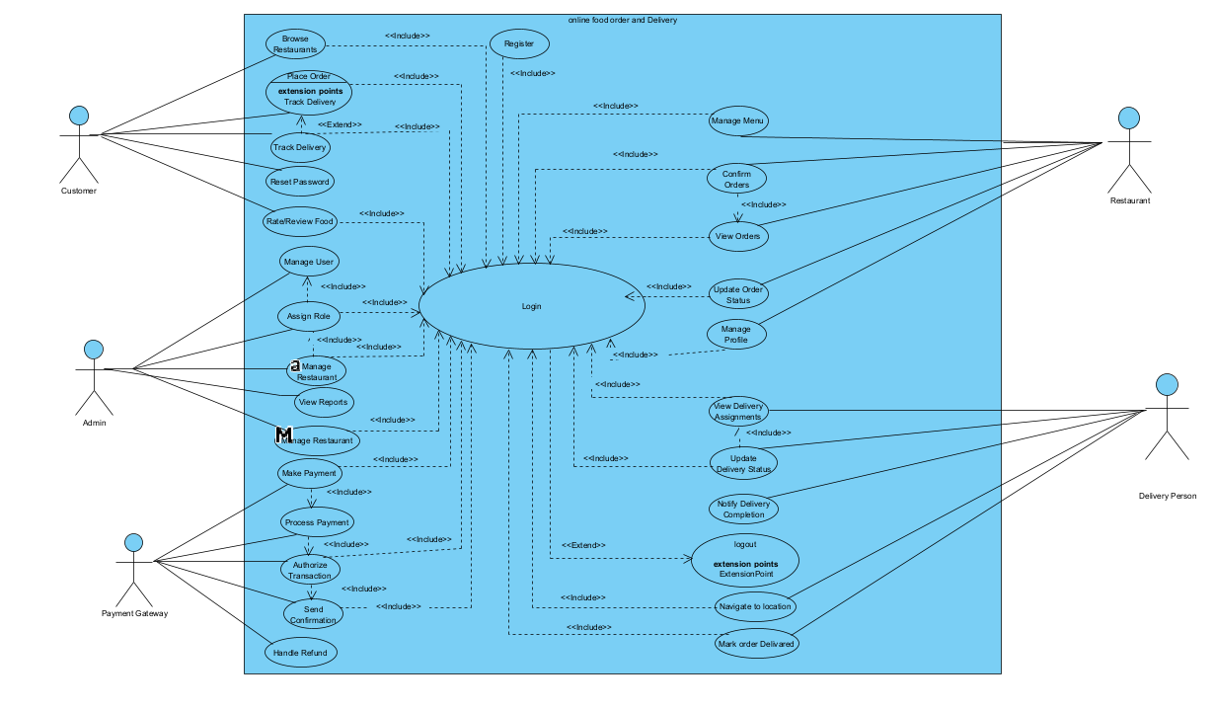
1.4.2 Use-Case Diagram.
Figure 4.1-1: Use case diagram for Online Food Order and Delivery System

1.4.3:Description of Use-Case/template.
Use Case ID | UC-1
Use Case Name | Register
Actor | Customer
Summary | This use case allows new customers to create an account on the food delivery platform by filling in their personal details.
Precondition | The user must have internet access.  2. The user must open the food delivery website or app.
Basic Scenario | Actor Action |  | System Response
Step1 | The user clicks the "Register" button. |  | Step2: The system displays a registration form.
Step3 | The user fills in the form and submits it. |  | Step4: The system checks the entered information.
Step6 | The user clicks on the verification link or enters a code. |  | Step5: The system sends a verification email or SMS.  Step7: The system confirms registration and logs in or redirects the user to the login page.
Alternative Scenario |  | Step8: If the user provides incorrect information in Step 3, the system shows an error message and asks the user to correct it.  Step9: If the user does not verify their account in time, the system deactivates the account and asks for re-registration.
Post Condition |  | The user is registered successfully. The system stores the profile and marks the account as active after verification.

Table 4.1-1: Use case description for create account/registration
Use Case ID | UC-2
Use Case Name | Login
Actor | Customer, Restaurant Owner, Delivery Agent, Admin
Summary | This use case describes the process for any user to log into the Online Food Order and Delivery Platform and access functionalities based on their role by entering valid account credentials.
Precondition | 1. The Online Food Order and Delivery Platform must be accessible 2. The user must have valid credentials (username/email and password) 3. The user must be registered and present in the database.
Basic Scenario | Actor Action | System Response
Step1 | The user navigates to the homepage and clicks the login button. | Step2: The system prompts the user to enter login credentials.
Step3 | The user enters their username/email and password into the respective fields. | Step4: The system verifies the entered credentials against the stored data.
Step5 | The user submits the login credentials. | Step6: The system authenticates the user's identity.
Alternative Scenario | Step8: The system displays an error message indicating incorrect username/email or password. | Step7: The system grants access to the user's respective dashboard.
 | Step8: The system displays an error message indicating incorrect username/email or password. | Step9: The user re-enters the credentials.
Post Condition | All users successfully log into the Online Food Order and Delivery Platform and gain access to their respective functionalities.

Table 4.1-2: Use case description for Login
Use Case ID | UC-3
Use Case Name | Log Out
Actor | Admin, Customer, Delivery person
Summary | This use case describes the process by which any user logs out of the online food order and delivery system, terminating their current session.
Preconditions | The system session must be active.  2. The user must be logged into the system.
Basic Scenario | Actor Action | System Response
Step 1 | The user initiates the logout process by clicking the "Log Out" button. | Step 2: The system prompts the user to confirm the logout action.
Step 3 | The user confirms the logout action. | Step 4: The system clears the session data associated with the user's account and prepares to log them out.
Step 5 | The system logs the user out and redirects to the login page. | Step 6: The system displays a confirmation message: "You have successfully logged out."
 |  | Step 7: The system provides options to return to the login page or exit the application.
Alternative Scenario | Actor Action
Step 1 | If the user's session expires due to inactivity:
Step 2 | The system automatically logs out the user and redirects them to the login page.
Step 3 | If the user cancels the logout process in step 2:
Step 4 | The system cancels the logout process, and the user remains in their current session/dashboard.
Post Condition | The user successfully logs out of the online food order and delivery system, ending their current session and returning to the login page.

Table 4.1-3: Use case description for Logout.
Use Case ID | UC-4
Use Case Name | Reset Password
Actor | Registered User
Summary | This use case allows users to reset their password if they forget it.
Precondition | The user must have access to their registered email or phone.
Basic Scenario | Actor Action.  Step1: The user clicks "Forgot Password".  Step3: The user enters their email or phone number.  Step5: The user enters the verification code and sets a new password. | System Response.  Step2: The system shows the password recovery page.  Step4: The system sends a verification code.  Step6: The system updates the password and confirms the change.
Alternative Scenario | Step7: If the entered information is incorrect, the system shows an error.
Post Condition | The user can now log in using their new password.

Table 4.1-3: Use case description for Reset Password.
Use Case ID | UC-5
Use Case Name | Manage Profile
Actor | Logged-in User
Summary | This use case allows users to view and update their profile information.
Precondition | The user must be logged in.
Basic Scenario | Actor Action,  Step1: The user goes to the profile section.  Step3: The user edits and saves changes. | System Response.  Step2: The system shows the user's profile.  Step4: The system updates the profile with the new information.
Post Condition | The user's profile is updated.

Table 4.1-4: Use case description for Manage Profile.
Use Case ID | UC-6
Use Case Name | Track Delivery
Actor | Customer
Summary | This use case lets the customer check the delivery status of their order.
Precondition | The customer must have placed an an order.
Basic Scenario | Actor Action.  Step1: The customer clicks on "Track Order". | System Response.  Step2: The system shows the current status of the delivery.
Post Condition | The customer sees the real-time location or status of their delivery.

Table 4.1-5: Use case description for Track Delivery.

Use Case ID | UC-7
Use Case Name | Manage Users
Actor | Admin
Summary | This use case allows the admin to view, edit, or delete user accounts.
Precondition | The admin must be logged in.
Basic Scenario | Actor Action.  Step1: The admin opens the user management section.  Step3: The admin selects a user and chooses to edit or delete the account. | System Response.  Step2: The system shows a list of users.  Step4: The system updates or removes the user account based on admin actions.
Post Condition | User information is updated or removed.

Table 4.1-6: Use case description for Manage Users.
Use Case ID | UC-8
Use Case Name | Assign/Revoke Roles
Actor | Administrator
Summary | This use case describes how the Administrator assigns or revokes roles (e.g., Customer, Delivery Personnel, Restaurant Manager) for users in the Online Food Order and Delivery System to manage access and responsibilities.
Precondition | The Administrator is logged into the system, and the target user account exists in the database.
Basic Scenario | Actor Action | System Response
Step1 | The Administrator navigates to the user management panel. | Step2: The system displays a list of registered users and their current roles.
Step3 | The Administrator selects a user to update roles. | Step4: The system displays available roles and the user’s assigned role(s).
Step5 | The Administrator selects the role(s) to assign or revoke.
Step6 | The Administrator submits the role changes. | Step7: The system updates the user's role(s) in the database.
 |  | Step8: The system notifies the Administrator that the roles were successfully updated.
Alternative Scenario | Step 9: If the Administrator attempts to revoke a mandatory role or assign a conflicting role: a. The system displays an error message. b. The Administrator adjusts the role selection to resolve the issue.
Post Condition | The user's role(s) are successfully updated in the system, and the Administrator receives confirmation.
|
Table 4.1-7: Use case description forAssign Roles.

Use Case ID | UC-9
Use Case Name | View Reports
Actor | Admin
Summary | This use case allows the admin to view system reports such as sales, orders, and user activity.
Precondition | Admin must be logged in.
Basic Scenario | Actor Action.  Step1: Admin navigates to the reports section.  Step3: Admin selects a report to view. | System Response.  Step2: System displays available report options.  .Step4: System generates and displays the selected report.
Post Condition | The admin views the desired report.

Table 4.1-8: Use case description for View Reports.
Use Case ID | UC-10
Use Case Name | Manage Menu
Actor | Admin / Restaurant Manager
Summary | This use case allows authorized users to add, edit, or remove menu items.
Precondition | User must be logged in with proper permissions.
Basic Scenario | Actor ActionStep1: User accesses the menu section.  Step3: User edits or adds new item details. | System Response.  Step2: System displays current menu items.  Step4: System updates the menu and confirms the changes.
Post Condition | Menu is updated with the new changes.

Table 4.1-9: Use case description for Manage Menus.
Use Case ID | UC-11
Use Case Name | Confirm Orders
Actor | Restaurant Manager
Summary | This use case allows the restaurant to confirm incoming customer orders.
Precondition | An order has been placed by the customer.
Basic Scenario | Actor Action.  Step1: Manager views pending orders.  Step3: Confirms the order. | System Response.  Step2: System lists new orders.  Step4: System marks the order as confirmed and notifies the customer.
Post Condition | The order is confirmed and ready for preparation.

Table 4.1-10: Use case description for Confirm Orders.

Use Case ID | UC-12
Use Case Name | Update Order Status
Actor | Restaurant Staff
Summary | This use case allows the restaurant to update the order status (e.g., preparing, ready for pickup).
Precondition | Order must be confirmed.
Basic Scenario | Actor Action.  Step1: Staff selects an order.  Step3: Updates the status. | System Response.  Step2: System shows order details.  Step4: System updates and notifies the user of the new status.
Post Condition | Order status is updated and reflected in customer view.

Table 4.1-11: Use case description for Update Order Status.

Use Case ID | UC-13
Use Case Name | View Delivery Assignments
Actor | Delivery Partner
Summary | This use case allows the delivery partner to view their assigned deliveries.
Precondition | Delivery partner must be logged in.
Basic Scenario | Actor Action.  Step1: Delivery partner navigates to "My Deliveries". | System Response.  Step2: System displays the list of assigned orders with details.
Post Condition | Delivery partner is aware of current delivery tasks.

Table 4.1-11: Use case description for View Delivery Assignments.
Use Case ID | UC-14
Use Case Name | Update Delivery Status
Actor | Delivery Partner
Summary | This use case allows the delivery partner to update the delivery status (e.g., picked up, delivered).
Precondition | Delivery must be assigned.
Basic Scenario | Actor Action.  Step1: Delivery partner selects an order.  Step3: Updates delivery status. | System Response.  Step2: System shows delivery details  .Step4: System updates the status and notifies the customer.
Post Condition | Delivery status is updated in the system.

Table 4.1-12: Use case description for Update Delivery Status.
Use Case ID | UC-15
Use Case Name | Browse Restaurants
Actor | Customer
Summary | This use case allows customers to browse available restaurants based on filters like cuisine, ratings, or distance.
Precondition | Customer must be logged in.
Basic Scenario | Actor Action.  Step1: Customer goes to restaurant section.  Step3: Applies filters/searches. | System Response.  Step2: System shows restaurant list.  Step4: System refines the list based on the input.
Post Condition | Customer can view suitable restaurants for ordering.

Table 4.1-13: Use case description for Browse Restaurants.
Use Case ID | UC-06
Use Case Name | Place Food Order
Actor | Customer
Summary | This use case allows customers to place an order for food items from a selected restaurant through the platform.
Precondition | 1. The customer must be logged into their account. 2. The selected restaurant and food items must be available for ordering.
Actor Action | System Response
Step1: The customer logs into the system and navigates to the Browse Restaurants section. | Step2: The system displays a list of available restaurants based on the customer’s location.
Step3: The customer selects a restaurant and browses its menu items. | Step4: The system displays item details including name, description, price, and availability.
Step5: The customer adds desired food items to the cart and selects quantity for each item. | Step6: The system updates the cart and calculates the total price.
Step7: The customer reviews the order, selects delivery address and payment method. | Step8: The system verifies the payment details and delivery availability.
Step9: The customer confirms and places the order. | Step10: The system displays a message: "Order successfully placed." Step11: The order is sent to the restaurant for preparation and added to the customer's order history.
Alternative Scenario | StepA1: If selected food items are out of stock or unavailable, the system notifies the customer and suggests similar items.
  St epA2: If the customer enters an invalid quantity (e.g., zero or negative), the system displays an error message and prompts for correction.
  StepA3: If payment fails, the system alerts the customer and requests an alternative payment method.
Postconditions | The order is saved in the system and marked as pending for preparation by the restaurant and for delivery by the assigned delivery personnel. The order is also added to the customer's order history for tracking.

Table 4.1-13: Use case description for Place Order.
Basic Information
Use Case ID | UC-07
Use Case Name | Checkout and Payment Processing
Actor | Customer
Summary | Allows a customer to complete a food order by submitting payment and receiving confirmation of payment success or failure
Preconditions | Condition
1 | The customer is logged into their account
2 | The customer has added items to the cart and initiated the checkout process
4 | Valid payment methods are available.

Main Flow (Normal Scenario)
stepe | Actor Action | System Response
1 | Customer initiates checkout. | System displays available payment methods.
2 | Customer selects payment method and submits payment info. | OrderService creates a pending order.
2.1 |  | Order Service saves the pending order in the Database.
2.2 |  | Database confirms the order is saved
2.3 |  | Order Service calls PaymentService to process payment.
2.4 |  | PaymentService sends payment details to PaymentGateway.
2.5 |  | PaymentGateway returns payment success/failure.

Alternative Flow A1: Payment Success

Step | Actor Action | System Response
A1.1 |  | Payment Service updates order status to “paid”.
A1.2 |  | Database confirms update.
A1.3 |  | Order Service triggers order fulfillment.
A1.4 |  | System confirms order success and displays success message to customer.

Alternative Flow A2: Payment Failure

Step | Actor Action | System Response
A2.1 |  | Payment Service updates order status to “failed”.
A2.2 |  | Database confirms update.
A2.3 |  | System notifies customer of payment failure and prompts retry.

Postconditions | Result
1 | On success, order is marked as 'paid' and order fulfillment is initiated.
2 | On failure, order is marked as 'failed', and user is prompted to retry payment.
3 | All events are logged for auditing and customer history.

Table 4.1-14: Use case description for Make Payment.,

Use Case ID | UC-18
Use Case Name | Rate Food
Actor | Customer
Summary | This use case allows customers to rate and review their food after delivery.
Precondition | Order has been delivered.
Basic Scenario | Actor Action.  Step1: Customer navigates to order history.  Step3: Leaves a rating/review. | System Response.  Step2: System displays past orders.  Step4: System saves the feedback.
Post Condition | Feedback is recorded and visible to other users/admins.

Table 4.1-15: Use case description for Rate Food.
Use Case ID | UC-19
Use Case Name | Process Payment
Actor | Payment Gateway System
Summary | This use case ensures payments are processed securely between customer, bank, and platform.
Precondition | Customer initiates a payment.
Basic Scenario | Actor Action.  Step1: Customer submits payment.  Step3: System communicates with gateway. | System Response.  Step2: System collects info.  Step4: Gateway processes and returns status.
Post Condition | Transaction is completed with success or failure message.

Table 4.1-16: Use case description for Process Payment.

Use Case ID | UC-20
Use Case Name | Verify Payment
Actor | System
Summary | This use case checks the success of a payment before order confirmation.
Precondition | Payment process has been initiated.
Basic Scenario | Actor Action.  Step1: System awaits response from gateway. | System Response.  Step2: System confirms or rejects order based on payment result.
Post Condition | Payment is verified and reflected in order status.

Table 4.1-17: Use case description for Verify Payment.
Use Case ID | UC-21
Use Case Name | Generate Receipt
Actor | System
Summary | This use case automatically generates a receipt after successful payment.
Precondition | Payment is verified and successful.
Basic Scenario | Actor Action.  Step1: Customer completes payment. | System Response.  Step2: System generates and displays/downloads receipt.
Post Condition | Customer receives receipt for the transaction.

Table 4.1-17: Use case description for Generate Receipt

1.5.1: Tools to Draw Use Case Diagrams.

1. Visual Paradigm (VP)
Type: UML Modeling Tool
Platforms: Desktop (VP Desktop), Online (VP Online)
Popular for: Use case diagrams, class diagrams, ERD, BPMN, and more.

Other Tools (for reference):
Lucidchart – Web-based diagramming tool
Draw.io (diagrams.net) – Free, browser-based
StarUML / Enterprise Architect – Desktop UML tools
MS Visio – Professional diagram tool (paid)

1.5.2: Steps to Draw Use Case Diagrams in Visual Paradigm.
Step 1: Open or Create a Project.
Launch Visual Paradigm (desktop or online).
Select "New Project" or open an existing one.
Step 2: Create a Use Case Diagram.
Go to "Diagram" → "New" → "UML Diagrams" → "Use Case Diagram".
Name the diagram (e.g., Food Delivery Use Cases).
Step 3: Add Actors.
· Select the "Actor" icon from the left-hand toolbar.
· Click on the canvas to place actors such as:
Customer.
Admin.
Delivery Partner.
Restaurant.
Step 4: Add Use Cases
Use the "Use Case" icon (oval shape).
Click to place and name use cases like:
Register
Login
Place Order
Make Payment etc.
Step 5: Connect Actors to Use Cases.
Use the "Association" (line) tool.
Click on an actor, drag to the appropriate use case.
Repeat for each actor-use case relationship.
Step 6: Use Include/Extend (if needed).
Use <<include>> or <<extend>> relationships:
Include: Common functionality (e.g., "Verify Payment" included in "Make Payment").
Extend: Optional behavior (e.g., "Rate Food" extends "Order Delivered")
Step 7: Organize and Label.
Rearrange actors and use cases for clarity.
Add system boundary box (rectangle) around use cases.
Step 8: Save and Export.
Save the project.
Use "File → Export → PNG, JPG, PDF" to export the diagram for reports or presentations.

Chapter Two

2.1 High-Level Sequence Diagram

A high-level sequence diagram is a type of UML (Unified Modeling Language) diagram that provides an overview of the interactions and sequence of events within a system. It focuses on the interactions between objects or components and the order in which these interactions occur. Here is an explanation of the components typically found in a high-level sequence diagram:
Objects/Components:
Objects or components participating in the interactions are represented as vertical lines (lifelines) on the diagram. Each lifeline represents an instance of an object or a component.
Messages:
Messages or actions exchanged between the objects/components are depicted as arrows between the lifelines. The arrows indicate the flow of communication or control between the objects/components.
Messages can be labeled to indicate the type of message, such as method calls, signals, or events. They may also include any parameters or arguments being passed.
Lifeline Ordering:
The vertical ordering of the lifelines on the diagram represents the sequence of interactions. Lifelines are typically arranged in the order in which the messages are exchanged, indicating the flow of control or data between the objects/components.
Activation Bars:
Activation bars, also known as activation rectangles, can be used to represent the duration or lifespan of an operation or method call. They show the period during which an object/component is actively processing a specific message.
System Boundary (Optional):
In some cases, a high-level sequence diagram may include a system boundary or scope box. This box visually represents the system being modeled and helps to define its boundaries.

2.2 Components of High-level Sequence Diagram
A high-level sequence diagram is a fundamental tool used in system modeling to represent the dynamic behavior of a system. It illustrates how various components interact over time through the exchange of messages. Each component in the diagram contributes to conveying the sequence, timing, and logic of system operations. Below are the detailed components of a high-level sequence diagram:
Actors
Actors are external entities that interact with the system. They can be:
Human users (e.g., customers, administrators).
External systems (e.g., payment gateways, third-party APIs).Actors initiate communication with the system by sending requests or triggering operations.
In diagrams:
They are usually depicted as stick figures or rectangles placed at the left or right edge of the diagram.
Their role is to begin the sequence of interactions by sending a message to a system component.

Lifelines
A lifeline represents an individual participant (object, class, subsystem, or actor) in the interaction.
Visually, it's shown as a vertical dashed line that descends from the actor or object label.
The top of the lifeline begins with the object or participant’s name.
The line continues downward to indicate the object's presence and lifespan during the scenario.
Lifelines are essential for illustrating when an object exists and when it participates in the sequence.
Messages
Messages are the core interactions between objects and actors in a sequence diagram.
Depicted as horizontal arrows from one lifeline to another.
Synchronous messages (calls that wait for a response) use solid arrows with filled arrowheads.
Asynchronous messages (calls that don’t wait for a response) use solid arrows with open arrowheads.
Return messages (responses) are often shown as dashed arrows.
Each message may include:
Method names.
Parameters passed.
Return values (in some cases)
Messages represent the flow of communication and drive the progression of the system’s behavior.
Activation Bars.
Also called execution occurrences, these are narrow rectangles drawn on a lifeline.
They indicate the active time during which an object is performing an operation or responding to a message.
They are vertically aligned with the lifeline and positioned where a message has been received.
Nested activation bars represent method calls within methods (i.e., one function calling another).
Activation bars help visualize which objects are active and engaged in processing at any point in the sequence.
Control Flow
Control flow refers to the logical sequence of operations in the system, determined by the ordering of messages.
The top-to-bottom layout of the diagram illustrates the temporal order of events.
Control flow ensures that:
Dependencies between actions are clear.
One event triggers the next logically and temporally.
The synchronization of messages is properly represented.
This helps developers and stakeholders understand how the system reacts under specific scenarios or inputs.

Optional Fragments (Interaction Fragments).
Interaction fragments are advanced modeling elements used in sequence diagrams to illustrate conditional, iterative, parallel, or referenced behaviors in system interactions. They are especially useful when depicting complex scenarios where actions do not follow a simple linear path. These fragments provide a structured way to handle variability in interaction flows, enhancing both the expressiveness and readability of the sequence diagram.
Each fragment is enclosed in a rectangular frame labeled with its type (e.g., alt, loop, opt, par, or ref) in the top-left corner, and may contain multiple operands or sections, depending on the logic being modeled.

Common Types of Interaction Fragments.
alt (Alternative) Fragment
Purpose: Represents a decision or branching logic, where only one of several possible paths is executed based on a condition.
Structure: Contains multiple operands, each with a guard condition (a logical expression in square brackets, e.g., [user is admin]).
Use Case Example: Different responses for valid and invalid login attempts.
Benefit: Clearly outlines mutually exclusive flows and decision-making logic.
opt (Optional) Fragment
Purpose: Models behavior that is conditionally executed. If the condition is true, the interaction inside the fragment occurs; otherwise, it is skipped.
Structure: Contains a single operand with a guard condition.
Use Case Example: Displaying a promotional banner only if the user is a first-time visitor.
Benefit: Highlights optional functionalities without cluttering the main sequence flow.
loop (Loop) Fragment
Purpose: Illustrates repetitive interactions that occur multiple times based on a defined condition.
Structure: Includes a guard condition specifying iteration constraints (e.g., [i < 3] or [while user enters incorrect password]).
Use Case Example: Password retry loop during login.
Benefit: Clearly shows iteration without repeating messages manually in the diagram.
par (Parallel) Fragment
Purpose: Represents actions or messages that occur concurrently or in parallel threads.
Structure: Each operand in the fragment occurs in parallel with others.
Use Case Example: Uploading a document while sending a confirmation email.
Benefit: Accurately models multi-threaded or asynchronous operations in a system.
ref (Reference) Fragment
Purpose: Embeds a reference to another sequence diagram, promoting modularity and reusability.
Structure: Contains a frame with the ref keyword and the name of the referenced diagram.
Use Case Example: Referring to a separate diagram for "Payment Processing" from the main checkout sequence.
Benefit: Reduces redundancy and improves clarity by isolating repeated or complex interactions.
By effectively utilizing interaction fragments, system designers and analysts can significantly enhance the expressiveness and accuracy of sequence diagrams. Rather than presenting a simple, linear progression of events, interaction fragments allow diagrams to mirror the dynamic nature of real-world systems—where decisions, repetitions, conditional behaviors, and parallel processes frequently occur. This level of detail helps bridge the gap between abstract design and real implementation.
Through the use of fragments such as alt, opt, loop, par, and ref, designers can:
Clearly model decision-making logic, ensuring all possible execution paths are accounted for.

2.3 Example of High Level Sequence.
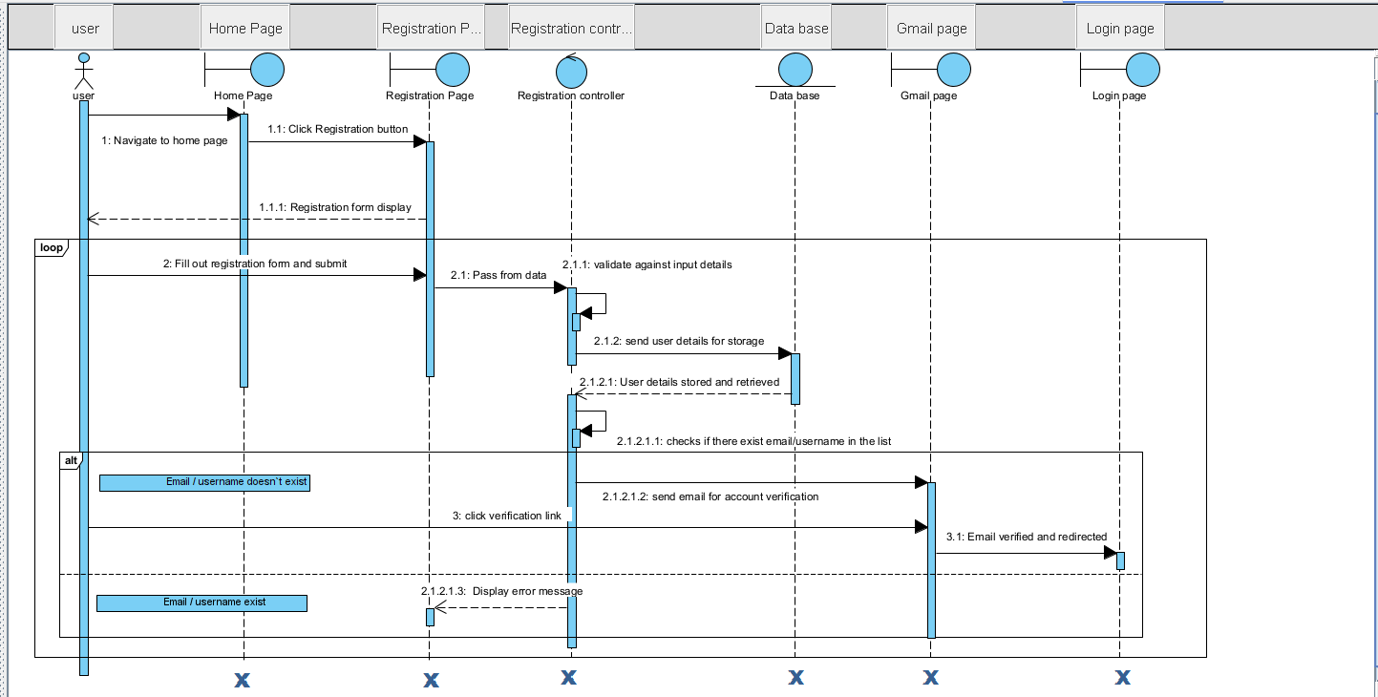

Figure 2.3-1: Sequence diagram for create account.

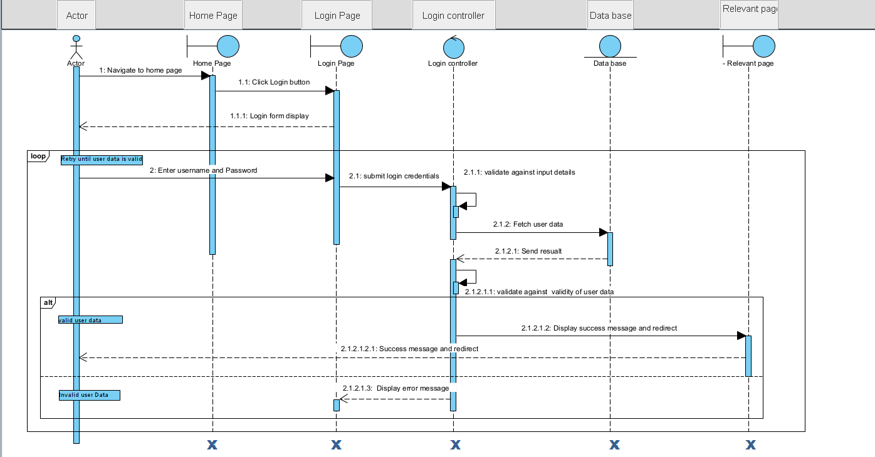

Figure 2.3-2: Sequence diagram for Log In.

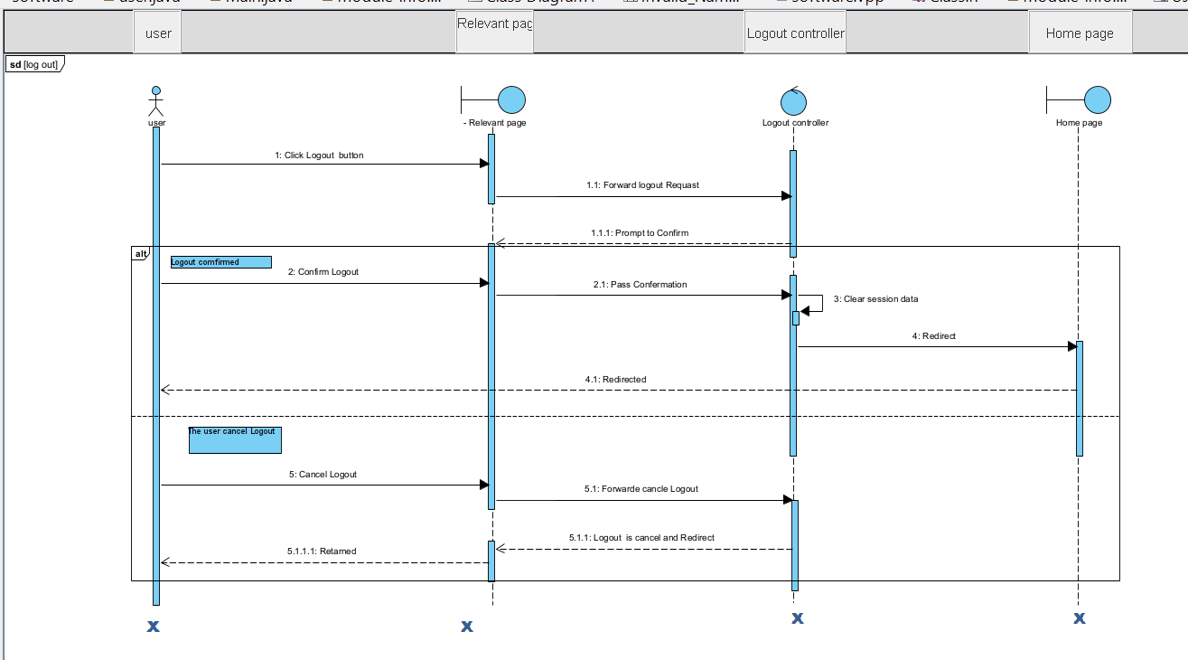

Figure 2.3-3: Sequence diagram for Log out.
.

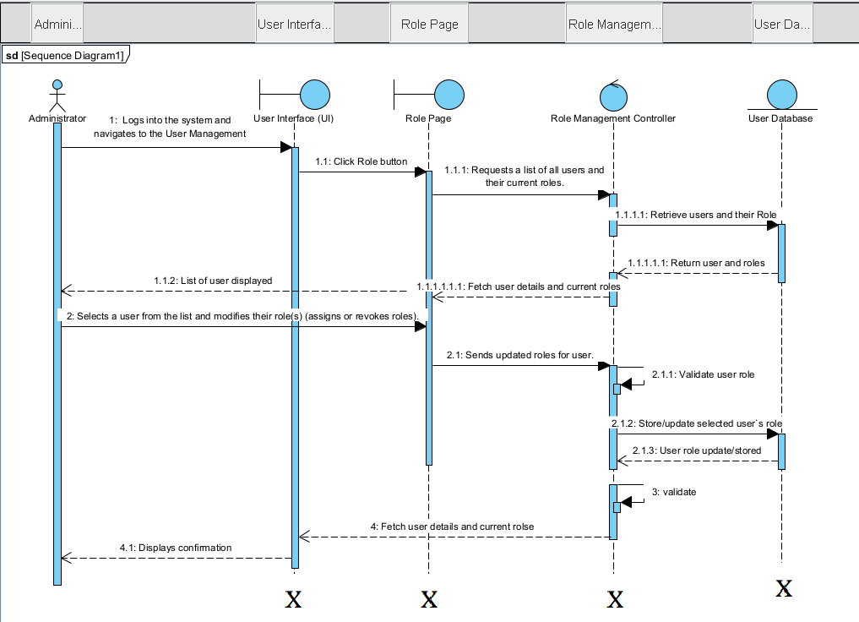

Figure 2.3-4: Sequence diagram for Assign Roles.

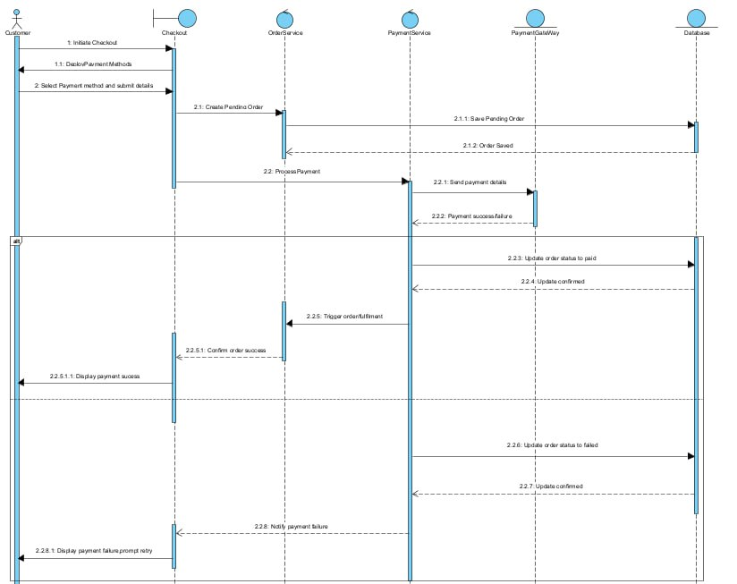
Figure 2.3-4: Sequence diagram for Make payment
.

2.4: Tools and Steps to Draw High Level Sequence Diagram.
To draw a High-Level Sequence Diagram, follow these steps and consider using the right tools. A sequence diagram is a type of UML (Unified Modeling Language) diagram that shows how objects interact in a particular scenario of a business process or system function.
Steps to Draw a High-Level Sequence Diagram.
Identify the Use Case or Scenario.
· Define the purpose: What functionality or process are you modeling?
· Example: User logs into an application.
Identify the Main Actors and Systems.
· These are the external entities (users or systems) that interact with your system.
· E.g., User, Login Service, Database.
List Key Objects or Components Involved.
· Identify the components within your system that participate in the scenario.
· E.g., UI, Authentication Service, User Profile DB.
Define the Sequence of Interactions.
· Determine how these entities interact step by step.
· Show the flow of messages or method calls between them.
Draw Lifelines and Messages.
· Each participant gets a lifeline (a vertical dashed line).
· Use arrows to indicate messages between participants (synchronous or asynchronous).
· Label each message clearly (e.g., validateUser()).
Include Activation Bars (Optional).
These show the time a component is active while handling a message.
Add Conditions or Loops (Optional).
Use guards like [if valid] or loops (loop) for repeated interactions.
Steps to Create a Sequence Diagram in Visual Paradigm.
Open or Create a Project.
· Launch Visual Paradigm.
· Create a new project or open an existing one.
Create a Sequence Diagram.
· Go to the Diagram Navigator (left panel).
· Right-click on UML Diagrams → Choose Sequence Diagram.
· Name your diagram appropriately (e.g., "User Login Flow").
Add Participants (Actors & Objects).
Drag Lifeline from the diagram palette onto the canvas.
Use lifelines to represent actors, systems, or components.
Rename them (e.g., User, UI, AuthService, Database).
Draw Messages.
• Use the Message tool to draw arrows between lifelines. For example: User → UI : enterCredentials() Then UI → AuthService : validateUser()

• Right-click messages to set type (synchronous, asynchronous, return).
5. Add Activation Bars (Optional)
• Visual Paradigm automatically adds them when a message is drawn.
6.Add Notes (Optional)
· Use the Note element to explain complex logic or assumptions.
· Drag a note and connect it to a lifeline or message.
Refine the Layout.
· Align lifelines evenly.
· Keep messages spaced clearly.
· Group related messages if needed.
9.Save and Export.
Save your project.
Go to File → Export → Active Diagram as Image/PDF to share or present.
Conclusion about Visual Paradigm.
Visual Paradigm is a powerful and user-friendly UML tool ideal for designing high-level sequence diagrams. It offers intuitive drag-and-drop features, supports all UML diagram types, and is well-suited for both beginners and professionals. Its export options, built-in templates, and collaboration features make it a complete solution for software design and documentation.

Chapter Three
Low-Level Design (LLD), also known as detailed design or class design, is a critical phase in the software development lifecycle that builds upon the foundation set by High-Level Design (HLD). While HLD focuses on system architecture, modules, and overall data flow, LLD delves deeper into the internal workings of each module by describing how the components are implemented using specific classes, methods, attributes, and interactions.
In the Online Food Order and Delivery System, the LLD translates abstract use cases (like “Place Order” or “Track Delivery”) into concrete object-oriented structures that developers can directly code. This includes defining each class with precise details about what data it holds (attributes), what operations it can perform (methods), and how it interacts with other classes in the system.

Key Concepts for Online Food Order and Delivery System.
Concept | Description (Specific to Online Food Delivery System)
Classes and Objects | Key classes include Customer, Restaurant, Order, MenuItem, DeliveryPerson, Admin, and PaymentGateway.
Attributes and Methods | Attributes include data such as orderId, menuList, status, and user credentials. Methods include behaviors such as placeOrder(), trackDelivery(), and processPayment().
Visibility | Attributes like passwords are private, while methods such as login() are public, ensuring proper encapsulation.
Inheritance | Customer, Admin, and DeliveryPerson inherit from a common abstract class User.
Association | A Customer places multiple Orders; each Order includes multiple MenuItems. A DeliveryPerson is associated with Order deliveries.
Aggregation and Composition | Restaurant aggregates MenuItems. Order has-a (composes) list of MenuItems—without them, the order is incomplete.
Dependencies | Order depends on Restaurant, Customer, and Payment classes to function correctly.
Design Patterns | The Factory Pattern can be used for creating different types of users (Customer/Admin). Observer Pattern may be used for order tracking updates.
Interfaces and Abstract Classes | An abstract class User defines shared login/logout behavior; interfaces could be used for payment gateway integration.

Table 3.1: Key Concepts of Low-Level Design for Online Food Order and Delivery System

Steps in Class Design
Step | Description (Applied to the System)
Identify Classes and Objects | Based on the use cases, we identify classes such as User, Order, MenuItem, Restaurant, DeliveryPerson, and Payment.
Define Class Structure | Each class is defined with relevant attributes (e.g., name, status, price) and methods (e.g., placeOrder(), confirmOrder(), navigateToLocation()).
Specify Methods and Attributes | Attributes are typed (e.g., String, double, Date), and methods define parameters, return types, and responsibilities. Example: calculateTotal(): double.
Establish Relationships | Relationships like one-to-many (Customer to Order) and composition (Order contains MenuItems) are diagrammed using UML.
Apply Design Patterns | Factory Pattern for user creation, Strategy Pattern for dynamic payment processing methods, and Observer for real-time order tracking.
Review and Refine | Design is peer-reviewed to ensure modularity, extensibility, and alignment with design principles like SOLID. Refactoring is done for clarity and maintainability.

Table 3.2: Class Design Steps for Online Food Order and Delivery System

3.2 Components of Class Diagram.
The class diagram is a core part of the Low-Level Design (LLD) and provides a static view of the system's structure. It details the system's classes, their attributes, methods, and relationships. For an Online Food Order and Delivery System, the major components are outlined below:
- Classes:
- Customer
Admin
Delivery Person
Restaurant
Order
MenuItem
PaymentGateway
User (Abstract class – parent to Customer, Admin, DeliveryPerson).
2. Attributes:
Customer: username: String ,password: String ,email: String ,address: String
phoneNumber: String .
Admin: adminId: String ,role: String ,DeliveryPerson: ,deliveryId: String
currentLocation: String ,availabilityStatus: boolean
Restaurant: restaurantId: String ,name: String ,location: String , menuList:List<MenuItem>

Order: orderId: int ,customer: Customer ,restaurant: Restaurant ,deliveryPerson: DeliveryPerson ,orderItems: List<MenuItem>
orderStatus: String ,totalAmount: double, paymentStatus: String
MenuItem: itemId: int ,name: String ,description: String ,price: double
3. Methods:
Customer: browseRestaurants() ,placeOrder(),trackDelivery(),rateFood(),resetPassword(),register(),login(),logout(),viewOrderHistory()
Admin: manageUsers(),assignRole(),viewReports(),manageRestaurantData(),login(),logout()
DeliveryPerson: viewDeliveryAssignments(),updateDeliveryStatus(),
navigateToLocation(),markOrderDelivered(),notifyCompletion(),login(),logout()
Restaurant: manageMenu(),confirmOrders(),viewOrders()updateOrderStatus(),
manageProfile(),login(),logout()
Order: addItem(item: MenuItem)removeItem(item: MenuItem),calculateTotal(): double ,updateStatus(newStatus: String ,processPayment(paymentInfo: String),
PaymentGateway:processPayment(),authorizeTransaction()sendConfirmation(),handleRefund()
5.Relationships:
Inheritance: Customer, Admin, and DeliveryPerson inherit from User (abstract class)
Association: Customer -- places --> Order,Order -- contains --> MenuItem (Composition) ,Restaurant -- provides --> MenuItem,DeliveryPerson -- assigned to --> Order ,Admin -- manages --> Restaurant and User ,Restaurant -- receives --> Order ,Order -- linked to --> PaymentGateway

3.4 Tools and Steps to Draw Low-Level Class Diagram
Tools
For designing the low-level class diagram of the Online Food Order and Delivery System, we used Visual Paradigm, a powerful UML modeling tool. Visual Paradigm supports advanced modeling features, including class diagrams, relationship mapping, visibility settings, and documentation of method signatures. It helps ensure consistency with software design best practices.
Steps to Draw the Low-Level Class Diagram
Step 1: Identify Classes
Begin by reviewing the system's functional and non-functional requirements as well as the use-case models. Identify the key classes that represent entities, actors, and services in the system. Each class should encapsulate a specific set of responsibilities.
Identified Classes:
User (Abstract Class) – Subclasses: Customer, Admin, DeliveryPerson
Restaurant, Menu, FoodItem, Order, Cart, Payment, Delivery, PaymentGateway
Step 2: Define Attributes
Define the attributes (data members) for each class. Attributes should capture the essential information needed by each entity.

Table 3.2 Define Attributies
Class | Attributes
User | userID, name, email, password, phoneNumber
Customer | Inherits from User; adds deliveryAddress, orderHistory
Admin | Inherits from User; adds role, accessLevel
DeliveryPerson | Inherits from User; adds vehicleType, availabilityStatus
Restaurant | restaurantID, name, location, cuisineType, rating
Menu | menuID, restaurantID, listOfFoodItems
FoodItem | itemID, name, description, price, category, availability
Cart | cartID, customerID, listOfItems, totalAmount
Order | orderID, customerID, restaurantID, orderDate, status, cart
Payment | paymentID, orderID, amount, paymentMethod, paymentStatus
Delivery | deliveryID, orderID, deliveryPersonID, deliveryStatus, ETA
PaymentGateway | gatewayID, providerName, apiKey, transactionStatus
Step 3: Determine Methods
Define the behavior (methods) that each class should perform to fulfill its responsibilities.,
Class | Methods
Customer | register(), login(), placeOrder(), viewOrderHistory()
Admin | login(), manageRestaurant(), viewReports()
DeliveryPerson | login(), updateAvailability(), trackDelivery(), confirmDelivery()
Restaurant | addMenu(), updateMenu(), viewOrders()
Menu | addFoodItem(), removeFoodItem(), updateFoodItem()
Order | addItem(), removeItem(), calculateTotal(), updateStatus()
Payment | processPayment(), verifyPaymentStatus()
Delivery | assignDeliveryPerson(), updateStatus(), trackDelivery()
PaymentGateway | authenticateTransaction(), sendPaymentRequest(), receiveConfirmation()

Step 4: Identify Relationships
Establish how the classes interact with each other. Use relationships like association, aggregation, composition, inheritance, and dependency.
Examples:
Customer places multiple Orders.
Order includes a Cart, is linked to one Payment and one Delivery.
Restaurant owns a Menu.
Menu contains many FoodItems.
Order is fulfilled by a DeliveryPerson.
Payment is processed via PaymentGateway.
Multiplicity Examples:
Customer 1..* — places — 0..* Order
Menu 1 — contains — 1..* FoodItem
Order 1 — has — 1 Payment
Order 1 — has — 1 Delivery
Step 5: Refine Class Responsibilities
Ensure each class follows the Single Responsibility Principle. Revise class roles so that each one has a focused purpose.
Step 5: Refine Class Responsibilities
Ensure each class follows the Single Responsibility Principle. Revise class roles so that each one has a focused purpose.
Class Responsibilities Overview:
Customer: User actions like placing and tracking orders.
Admin: System management, menu approval, analytics.
Restaurant: Menu and order processing.
Menu: Collection of food items for a restaurant.
Order: Links customer, food items, payment, and delivery.
Payment: Handles transaction and confirmation.
Delivery: Manages order dispatch and tracking.
Payment Gateway: Interfaces with third-party financial services.
Step 6: Draw the Class Diagram
Use Visual Paradigm to create the class diagram:
• Drag and drop classes.
• Add attributes and methods with appropriate visibility modifiers.
• Connect classes using UML relationships.
Step 7: Add Detailed Notations
Enhance the diagram with data types, method signatures, attribute visibility, and multiplicity on associations.
Step 8: Review and Iterate
Review and refine the class diagram to ensure alignment with system requirements and object-oriented design principles.

Chapter Four

4.1 Implementation
Implementation refers to the process of translating a plan, idea, model, or design into an operational form. In the context of software development, it means converting system designs, diagrams, and specifications into executable code. This phase is crucial as it turns theoretical models into practical, working software. Implementation involves writing the actual code that performs the functions and processes defined in the system architecture, use-case models, and class diagrams.
In this project, implementation was guided by the previously defined UML class diagrams. Each class was converted into a software component using the appropriate programming language. Relationships such as inheritance, associations, and dependencies were preserved in the code structure to ensure maintainability and reusability.
Table 4.1: Class Diagrams
Term | Description
Class Diagram | A type of static structure diagram that shows classes, their attributes, methods, and the relationships among them.
Class | A blueprint for objects. It encapsulates attributes and methods relevant to a specific entity.
Attributes | Variables that define the state or properties of a class. Represented as fields or data members.
Methods | Functions or procedures defined within a class to implement behavior or operations.
Relationships | Connections between classes such as associations, aggregations, compositions, and inheritance.
Visibility | Access control for class members, such as public, private, and protected, used to enforce encapsulation.
Object | An instance of a class created during the execution of the program.
Constructor | A special method used to initialize new objects of a class.
Interface | A collection of method definitions that implementing classes must provide.
Inheritance | A mechanism where a subclass inherits properties and behavior from a superclass. Enables code reuse.

4.2 Steps to generate code from class diagram
Step | Description
Identify Classes and Relationships | Review the class diagram to understand the classes, their attributes, methods, and how they are related (inheritance, associations, etc.).
Define Classes | Create the class in your chosen programming language. Each class in the diagram becomes a class in your code.
Add Attributes | Add the attributes (variables) to each class as shown in the class diagram.
Implement Methods | Define methods (functions) for each class. The methods should match those shown in the class diagram.
Establish Relationships | Implement relationships such as inheritance and associations. For example, use inheritance to extend a class, or use member variables to establish associations.
Write Constructors and Destructors | Implement constructors for initializing objects and destructors if necessary for clean-up.

Table 4.2: Steps to generate code from class diagram

